CSSE1001 Project 3

PyWire

Design Document

Liam Maruff, 41730654
Contents

- Abstract ………………………………………………………………………………..  - Design …………………………………………………………………………………..  - Application Flow …………………………………………………………………...  - A Note on Plug-Ins and Virtual Methods …………………………………  - Application Classes ………………………………………………………………..  - InterpCmd ……………………………………………….……….  - Circuit ……………………………………………………….……..  - Workspace ……………………………………………………….  - Analysis ……………………………………………………………  - Component ………………………………………………………  - ComponentFactory ……………………………………………  - AnalysisFactory ………………………………………………..  - ComponentInstance …………………………………………..  - Application methods...……………………………………………………………..  - Exceptions ……………………………………………………………………………..  - Modules …………………………………………………………………………………  - Module structure ………………………………………………  - Additional modules …………………………………………...  - Plugin interface: General overview…..……………………………………… | 3  3  3  3  4  4  5  6  9  9  10  11  11  11  13  13  13  14  15

Abstract

The objective of PyWire is to design a flexible, extensible application which allows the design and analysis of circuitry.

The system, at its lowest level, allows the design and analysis of analogue electronic circuits; however, by taking advantage of Python’s ability to run python modules at runtime, PyWire will allow the creation of user made components; allowing the system to cater to most any need. The level of abstraction and number of objects which are plug-ins allows the system to be completely reworked, should the user deem necessary. The actual code which defines PyWire as an application will be kept to a minimum, with all functionality being defined by additional Plug-In modules, created as .py files.

The application is a console application; however, it is intended that, through plug-in’s, it would be possible to add a GUI to the application with relative ease.

Design

Application Flow

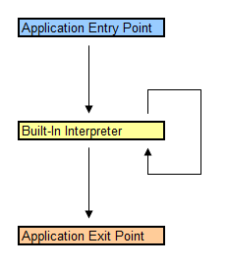
The flow of PyWire is simple, and consists of 3 stages, each defined by a method:

- Application Entry Point – AppEntry
- Built-In Interpreter – AppRun
- Application Exit Point – AppExit

During the application entry phase, plug in modules are loaded, session variables are created, and error logging begins.

The built in interpreter is responsible for managing circuits: creating, destroying, editing, selecting, deselecting, in addition to handling parts and analysis methods.

Upon receiving the correct command, the built in interpreter exits its control loop, and the program flow enters the exit phase. Session variables are cleaned up, and the application is destroyed. Python handles all dynamic memory allocations through garbage collection.

A Note on Plug-Ins and Virtual Methods

Python, as a language, doesn’t support virtual functions per se; in the context of this documentation, a virtual function defines an interface which it is intended will be overridden in a plug-in component. A virtual function may be defined when needed; a pure virtual function will throw an exception if it is undefined.

Furthermore, By executing commands in the global namespace, we open up a whole range of possibilities as to what can be achieved via plug ins.
Application Classes

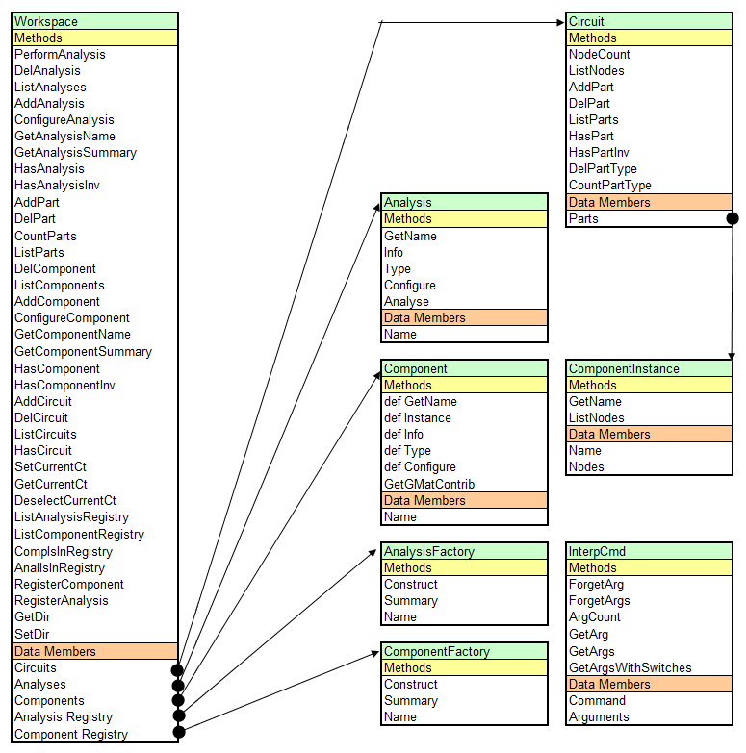

The image above shows the general structure and relationship between the main workspace class, and the various sub classes.

In general, the workspace stores circuits, and factories. The factories construct components and analysis’s, which are returned to the workspace, and stored for use.

The analysis’s are used from the workspace, however the components are then instanced, and those instances are placed in circuits. These instances retain the name of the component they are instances of, so they can can be mapped back when they are parsed into an analysis.

InterpCmd

Encapsulates the iea of a command, and handles argument organisation, storage and retrieval.

Methods

__init__(self, str_input, cmd_sep = " ", arg_sep = ",")

Initialises the InterpCmd based on the input, the command seperator and the arguments seperator.

ForgetArg(self, arg_no)

Deletes an argument.

ForgetArgs(self, arg_nos)

Deletes several arguments.

ArgCount(self)

Count how many arguments were supplied.

GetArg(self, arg_no, arg_type, default_val = ",no: ;val,")

Get an argument.

GetArgs(self, arg_data)

Get several arguments.

GetArgsWithSwitches(self, switch_data, on_fail_append_none = True)

Circuit

Holds parts, defines the actual electrical circuit.

Data Members

Parts

Dictionary of the parts in this circuit, indexed by their name.

Methods

NodeCount(self)

Returns the number of nodes in this circuit.

ListNodes(self)

Returns a list of the nodes in this circuit.

AddPart(self, pt_name, part)

Adds a part to this circuit, under pt_name.

DelPart(self, pt_name)

Deletes a part from this circuit, named pt_name.

ListParts(self)

List the parts in this circuit; throws an exception if the circuit has no components.

HasPart(self, pt_name)

Check if this circuit has a given part, throws an exception if it doesn’t.

HasPartInv(self, pt_name)

Checks if a circuit has a given part; throws an exception is it does.

DelPartType(self, pt_type)

Delete all parts of a given type.

CountPartType(self, pt_type)

Return the number of parts in this circuit, of a given type.

Workspace

The Workspace class, a singleton which holds all of our run-time variables, includuing our circuits, components, and analysis methods.

Data Members

Circuits

The circuits we’ve made so far.

Components

The components we've made from factories.

Analyses

The analyses we’ve made from factories.

COMPONENT_REGISTRY

The dictionary of component factories, indexed by name.

CURRENT_CT

The currently selected circuit.

ANALYSIS_REGISTRY

The dictionary of analysis factories, indexed by name.

DIRECTORY

The current directory were in, used for file i/o.

Methods

PerformAnalysis(self, as_name, ct_name, args)

Perform a given analysis on a circuit.

DelAnalysis(self, as_name)

Delete an analysis.

ListAnalyses(self)

List analysis currently available. Throws exception if none exist.

AddAnalysis(self, reg_str, as_name, args)

Add a new analysis made from factory reg_str.

ConfigureAnalysis(self, as_name, args)

Change settings for an analysis.

GetAnalysisName(self, reg_str)

Get the name of an analysis.

GetAnalysisSummary(self, reg_str)

Get a brief summary of an analysis.

HasAnalysis(self, as_name)

Check if analysis exists, if not, throw an exception.

HasAnalysisInv(self, as_name)

Check if analysis exists, if so, throw an exception.

AddPart(self, pt_name, cp_name, ct_name, args)

Add a part from a given component.

DelPart(self, pt_name, ct_name)

delete a part by name.

CountParts(self, cp_name)

Count how many instances of a component there are.

ListParts(self, ct_name)

List the parts in a circuit, throw exception if none.

DelComponent(self, cp_name)

Delete a component.

ListComponents(self)

List components, throw an exception if there are none.

AddComponent(self, reg_str, cp_name, args)

Add a component, throw an exception on error.

ConfigureComponent(self, cp_name, args)

Configure a componenet.

GetComponentName(self, reg_str)

Get the name of a component.

GetComponentSummary(self, reg_str)

Get a summary of a component.

HasComponent(self, cp_name)

Check if component exists, if not, throw an exception.

HasComponentInv(self, cp_name)

Check if component exists, if so, throw an exception.

AddCircuit(self, ct_name)

Add a circuit to the workspace.

DelCircuit(self, ct_name)

Delete a circuit from the workspace.

ListCircuits(self)

List circuits in workspace, throw exception if there are none.

HasCircuit(self, ct_name)

Check if workspace has circuit, if not, throw exception.

SetCurrentCt(self, ct_name)

Set the currently selected circuit.

GetCurrentCt(self)

Get the currently selected circuit.

DeselectCurrentCt(self)

Deselect currently selected circuit.

ListAnalysisRegistry(self)

List the analysis factories in the registry.

ListComponentRegistry(self)

List the componenet factories in the registry.

CompIsInRegistry(self, reg_str)

Check if componenet is in registry, throw excpeption if it isn’t.

AnalIsInRegistry(self, reg_str)

Check if analysis is in registry, throw excpeption if it isn’t.

RegisterComponent(self, reg_str, component_factory)

Add a component factory to the registry.

RegisterAnalysis(self, reg_str, analysis_method)

Add an analysis factory to the registry.

GetDir(self)

Get the current directory we're in.

SetDir(self, str_path)

set the current directory.

Analysis

Defines an analysis method, abstract class.

Data Members

Name –The name of the analysis.

Methods

__init__(self, name)

Initialises the analysis, setting the name variable to the supplied value.

GetName(self)

Retrieves the name stored in Name.

Info(self)

Returns a string describing this analysis; it’s settings etc.

Type(self)

Returns a string indicating the type of this analysis method.

Configure(self, args)

Reconfigre the analysis, on the basis or the arguments supplied in args.

Analyse(self, circuit, components, args)

Analyses circuit, which contains components stored in components, based on the parameters in args.

Component

Defines a component, which is then instanced by parts in the circuits.

Data Members

Name –The name of the analysis.

Methods

NodeCount(self)

Returns the number of nodes in this circuit.

__init__(self, name)

Initialises the component, setting the name variable to the supplied value.

GetName(self)

Retrieves the name stored in Name.

Instance(self, args)

Instances the component based on the arguments in args.

Info(self)

Returns a string describing this component; it’s settings etc.

Type(self)

Returns a string indicating the type of this component.

Configure(self, args)

Reconfigre the component, on the basis or the arguments supplied in args.

GetGMatContrib(self, gmat, ivec, instance)

Return the components contribution to the conductance matrix and current vector, with regard to the given instance.

ComponentFactory

Defines an component factory, which builds components to be instanced within circuits.

Methods

Construct(self, name, args)

Construct an component, based on arguments in args.

Summary(self)

Returns a summary of this component; its usage, etc.

Name (self)

Retrieves the name of this component factory.

AnalysisFactory

Defines an analysis factory, which builds components to be instanced within circuits.

Methods

Construct(self, name, args)

Construct an analysis, based on arguments in args.

Summary(self)

Returns a summary of this analysis; its usage, etc.

Name (self)

Retrieves the name of this analysis factory.

ComponentInstance

A component instance, used for parts in a circuit as instances to the actual components.

Data Members

Name –The name of the analysis.
Nodes –The nodes connected to this instance.

Methods

GetName(self)

Get the name of the component this is an instance of.

ListNodes(self)

Return a list of the nodes this component instance is connected to.

Application Methods

Interpret(int_cmd)

Iterpret a command.

AppRun()

Run the application.

AppEntry(ini_fn = "init.ini")

The application Entry Point

AppExit()

Exit the application.

GetFileDataAsLines(filename)

Return a Data file as a list of the lines it contains.

ExecScript(plugin_filename)

Execute a file as python code.

Furthermore, a corresponding method which accepts a single argument of type InterpCmd should be defined for each of the following VALID input commands:

sel_current | Query the current selection.
ct_create ct_name | Create a circuit named ct_name.
ct_destroy ct_name | Delete a circuit named ct_name.
ct_list | List all current circuits.
ct_select ct_name | Select a circuit named ct_name.
ct_deselect | Deselect currently selected circuit.
cp_create cp_type, cp_name, … | Create a new component of type cp_type named cp_type, with optional arguments as designated by the component implementation.
cp_delete cp_name | Delete component named cp_name.
cp_list | List all current components.
cp_inventory | List all component types registered for use.
cp_config cp_name, … | Configure component named cp_type, with optional arguments as designated by the component implementation.
cp_countinstances cp_name | Count how many instances of component cp_name occur in all circuits.
pt_add cp_name, pt_name, … | Add a part pt_name as an instance of cp_name, with optional arguments as designated by the part implementation.
pt_list | List all parts in the current circuit.
pt_delete pt_name | Delete part pt_name from the current circuit.
as_create as_type, as_name, … | with optional arguments as designated by the analysis implementation.
as_delete as_name | Delete analysis named as_named.
as_list | List current analyses.
as_inventory | List all analysis types registered for use.
as_config as_name, … | with optional arguments as designated by the analysis implementation.
as_analyse as_name, ct_name | Perform analysis as_name on circuit ct_name.
fl_exec_raw filename | Execute file filename in the default directory, as raw python code.
fl_exec_cmds filename | Execute file filename in the default directory, as a PyWire script.
fl_getdir | Query the current directory.
fl_setdir filename | Set the current directory.

These are then to be indexed in a dictionary, and called from there by the interpreter.

PrintAndLogGExcept(indent_level = 1)

Print the current exception to the screen and the general log file.

PrintAndLogG(a, indent_level = 1)

Print string to the screen and general log file.

LogGWriteSeperator()

Write a seperator to the general log and the screen.

LogC(a)

Write textto the command log.

WriteLogs(fns, fnc)

Write logs to file.

DumpLogs(fns, fnc)

Write logs to file, and then clear logs.

ClearLogs()

Clear logs.

Exceptions

PURE_VIRTUAL_UNDEFINED – A pure virtual method is undefinded. Used to compensate for Python’s lack of virtual methods (C++ style).
SYSTEM_INIT_FAIL – System initialisation failure; PyWire cannot start.
NO_SUCH_FILE – File not found.
GENERAL_FILE_ERROR – File not found, or file invalid.
INVALID_VALUE – General error used where values passed in or out of variables are invalid for the return type.

Modules

Module Structure

Analysis.py:

Classes:

- AnalysisFactory
- Analysis

Component.py:

Classes:

- ComponentFactory
- Component
- ComponentInstance

Logging.py:

Methods:

- PrintAndLogGExcept
- MakeIndent
- PrintAndLogG
- LogGWriteSeperator
- LogC
- WriteLogs
- DumpLogs
- ClearLogs
- __WriteLog

Main.py:

Methods:

- GetFileDataAsLines
- ExecScript
- Interp_ct_select
- Interp_ct_destroy
- Interp_ct_deselect
- Interp_ct_create
- Interp_ct_list
- Interp_sel_current
- Interp_fl_setdir
- Interp_fl_getdir
- Interp_fl_exec_raw
- Interp_fl_exec_cmds
- Interp_as_create
- Interp_as_analyse
- Interp_as_config
- Interp_as_delete
- Interp_as_inventory
- Interp_as_list
- Interp_cp_create
- Interp_cp_config
- Interp_cp_delete
- Interp_cp_inventory
- Interp_cp_list
- Interp_cp_countinstances
- Interp_pt_add
- Interp_pt_list
- Interp_pt_delete
- Interpret
- AppRun
- AppEntry
- AppExit

Classes:

- InterpCmd
- Circuit
- Workspace

Additional Modules

PyWire takes advantage of module “Matrix2D.py”, written by Scott Hurring, 2006. This module is freely distributed without any express license, and was obtained from:

http://hurring.com/code/python/matrix2d/
Plugin interface: General overview

PyWire takes advantage of dynamic code execution in python, and sues this to load plug ins at run time. There are two types of plug ins, each created by inheriting from and overriding several classes:

Component Plugin:

- ComponentFactory
- Component
- ComponentInstance (optional)

Analysis Plugin:

- AnalysisFactory
- Analysis

Once the classes have been overloaded, the filename must be added to the .ini file which lists the python scripts to be run on program entry.

The final step is to ensure that, in the plugin files, the component/analysis has been registered with the default workspace (GLOBAL), like so:

GLOBAL.RegisterComponent(…)
GLOBAL.RegisterAnalysis(…)

